# **BLEAGLE GENERAL DEALERS LIMITED**

KAPALU BWALYA PHILIP

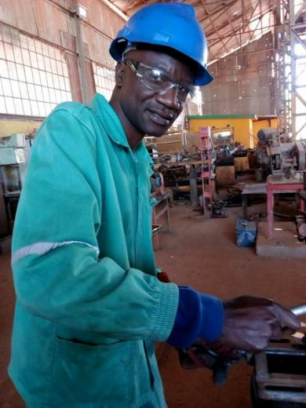

**DESCRIBE YOUR BUSINESS:**

BLEALE GENERAL DEALERS LIMITED is a registered company with PACRA and currently has more than 10 customers, when we are given the EntrApov loan, we will buy our own welding equipment (**a welding machine at $200, a genset at $520, hand grinding machine at $140, and a hand drilling machine at $140**). The equipment will boost our business and increase our revenue because currently, we are just hiring at a high cost.

**DESCRIBE THE PROBLEM**

In our area, a lot of people are building and they are struggling with where to get/buy windows and door frames.

**EXPLAIN YOUR SOLUTION:**

We will bring these items right to their doorstep at high quality and at an affordable price.

**BUSINESS MISSION STATEMENT:**

As ***BLEAGLE GENERAL DEALERS LIMITED,*** we are an engineering company and general suppliers of goods and services that are there to meet the needs of our clients at high quality but affordable, we manufacture different engineering products ranging from fabrication to machining mining and general engineering products. Our target audience range from home builders to mining companies to meet their day-to-day needs.

**HOW LONG HOW YOU BEEN IN BUSINESS?**

For three years.

**YOUR NET INCOME**

Our net income ranges from between $171 to $214 our total expenses range from between $108 to $190 at most and our profit is in the range of $63 to $108 this is mostly because we are currently just hiring the equipment we use in our business.

**SERVICE OR PRODUCT DELIVERABLE:**

We will be producing high-demand products in the construction and mining industry, we will be producing windows, door frames, tank stands, gates on the household level, and couplings, pins,s and other mining equipment for the mining industry as we expand our business in the next three to five years.

**DESCRIBE YOUR BEST CUSTOMER:**

Who is your customer? Our best customer is **Mate World, a construction** company that does a lot of construction work and they usually engage us to do fabrication jobs for them and we have a very good work relationship with the CEO of this company.

**WHY CUSTOMERS DO BUSINESS WITH YOU RATHER THAN WITH YOUR COMPETITORS?**

We are efficient and reliable with the delivery of our products and services, and we are so committed to what we do. Our prices and quality are unmatched.

**LIST YOUR SERVICES OR PRODUCTS AND THEIR PRICES:**

| **Item** | **Price with customer material** | **Labor charge** | **Price with our material** |
| --- | --- | --- | --- |
| **Metal Gate** | **$260** | **$75** | **$340** |
| **Metal Window Frame** | **$140** | **$85** | **$230** |
| **Water Tank Stand** | **$550** | **$190** | **$760** |
| **Grill Door** | **$120** | **$70** | **$200** |

**HOW DO CUSTOMERS KNOW THAT YOU EXIST?**

We are a community-based company, and we are strategically located, in an area where products and services are needed. Our most important marketing strategy is the quality and price of our products and services, so we usually get referrals from our previous customers.

**WHY DID YOU CHOOSE THIS BUSINESS:**

Products and services are on demand and their demand never ends I have a lot of experience in this field of over 15 years, so it’s something I have an understanding of.

**LIST YOUR TOP WAYS TO FIND NEW CUSTOMERS:**

- Location of the business.

- Quality of the products and services.

- Advertising.

**Insert pictures of your business activities here and give a brief explanation of each:**

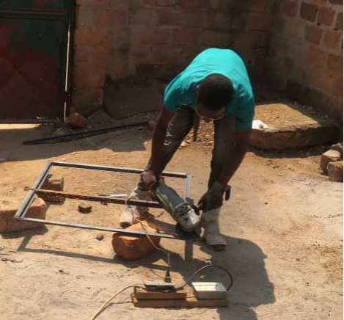

**This is a metal gate and it’s made with tubes and iron sheets are the only materials used. They are sold at $260 if materials are provided or labor of $75.**

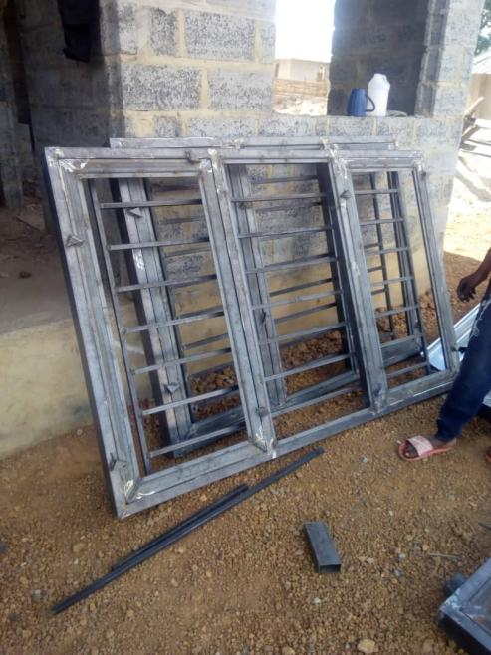

- **This is a 2m/900 cm window frame for a house under construction, it’s also made according to customer needs, design, and budget. They are sold at $120 if we provide the materials or just labor of $24.  
We do make water tank stands as well.**

**HOW WILL YOU USE THE MONEY?**

1.⁠ ⁠Grinder $90.74

2.⁠ ⁠Electric Drill $43.8

3.⁠ ⁠Welding machine $170

4.⁠ ⁠Generator $600

5. Fuel $95.46

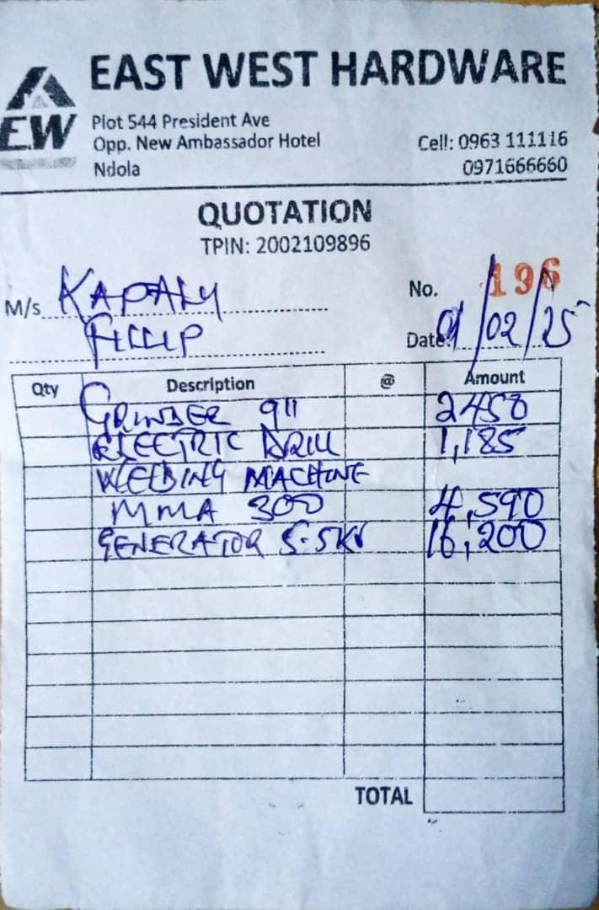  
We plan to purchase a Genset, Welding Machine, Grinder, and Drilling Machine.

**Insert pictures of your income statement here:**

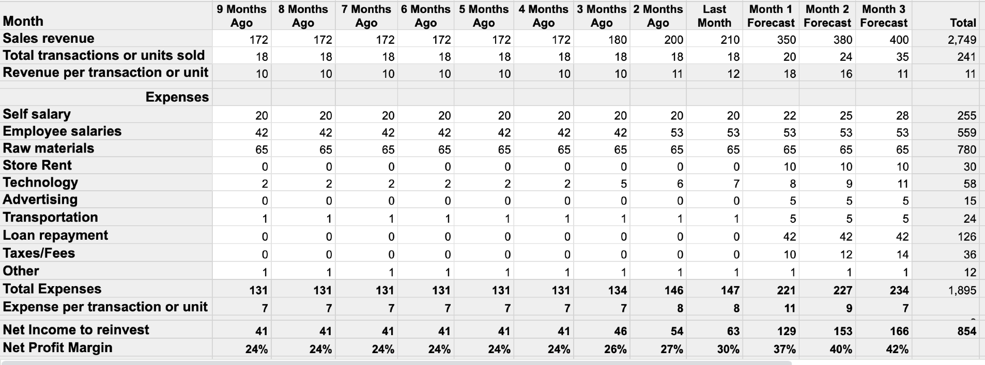

**Insert pictures of the cash flow statement here:**

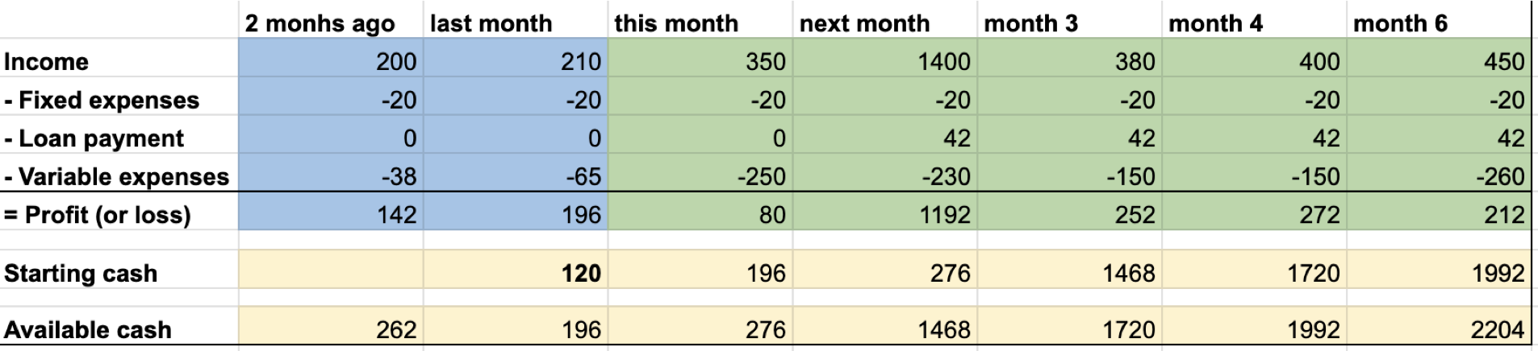

**What is the common cause for this common to fail?**

According to my research on this business, the main cause for this kind of business's failure is simply the ability to understand the dynamics of doing this kind of business by being more interested in making more money than quality products. As BLEAGLE GENERAL DEALERS LIMITED, we are committed to providing quality and durable products to our clients.

**Share about your family and picture here:**

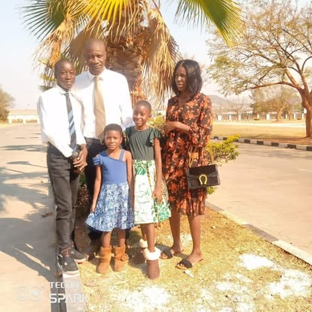

I love my family so much and I am striving to make sure that I provide for them both physically and spiritually because I understand that, that’s the divine calling I have received from my heavenly father and this company will be able to help us take care of our needs as we strive to become self-reliant.

**CONTACT DETAILS:**

Phone number: +260968369679

Email: philipbwalyakapalu@ymail.com

**Course Facilitator Details**

Phone: +260973838304

Email: muka2002@gmail.com